Table of Contents
1 Log in 2
1.1 Create a new account 2
1.2 Edit my details 3
1.3 GPS location tracking 3
1.4 Log out 3
2 I want to give stuff 3
2.1 Give a new item 3
2.2 View / edit / delete my items 3
3 I want to get stuff 4
3.1 Search for stuff 4
3.2 View item's details 4
3.3 Get directions to item's location 5
3.4 Create / edit / delete a smart agent 5

Log in
If you already have a Freebay account, type in your user name and password on the application's main page and log in to Freebay. After your details will be verified you will be transferred to the application's home page. That is the page that encapsulates all of the main features of Freebay. Later on, when you'll navigate between the other Freebay pages, you can always go back to this page by clicking the phone's built in 'back' button, or by clicking the 'home' icon which appears on all of the pages.
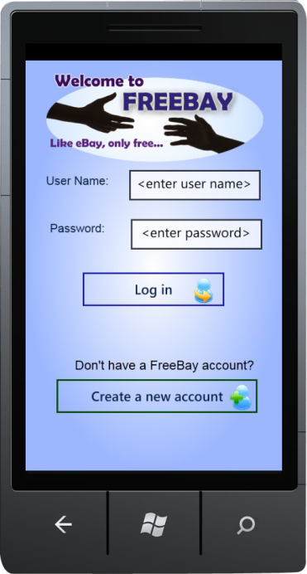
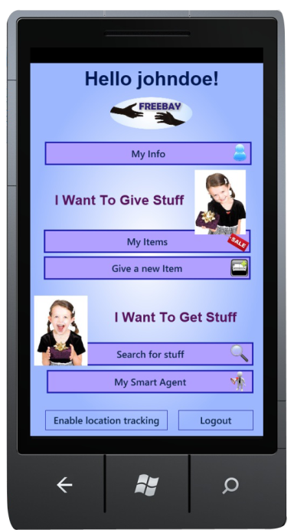

Create a new account
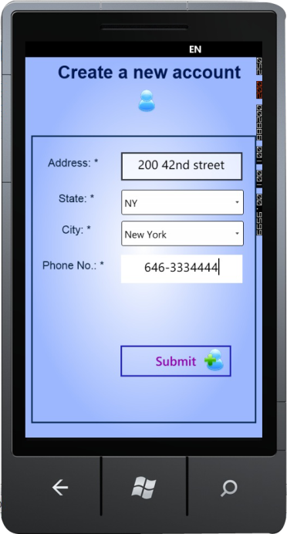
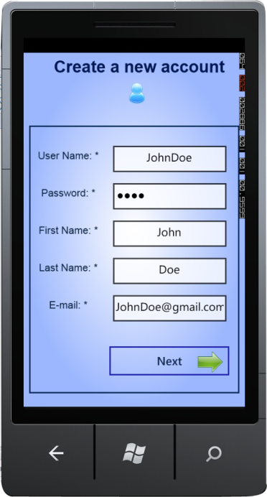
If you don't have a Freebay account, click the "Create new account" button, and then fill in user name, password (minimum 4 characters), full name and e-mail address, and then click 'next'. On the next page, fill in your home address, city, state and phone number, and then click 'Submit'. You will be transferred to the application's home page (see previous section for more details).

View / Edit my details
On the application's home page, click on 'My Info' button and you will be able to view or edit your personal details. For editing click 'submit'.

GPS location tracking
In order for Freebay to get its full functionality, the application tracks your location by default. If you're not interested in that, you can manually disable it by clicking on the 'enable / disable location tracking' button on Freebay's home page.

Log out
Simply click the 'Log out' button on the application's home page.

I want to give stuff

Give a new item
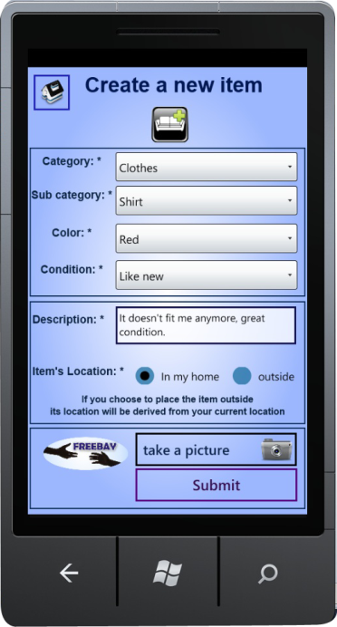
On the application's home page, click on 'Give a new item' button and fill in the item's details: category, sub category, color and condition, and add a short description of the item. You can also take a picture of the item by clicking on 'take a picture' button. Decide whether you wish to place the item in your home or at your current location outside. If you choose to place the item outdoors, its location will be derived by your current position, so please make sure your GPS service is enabled. In addition, your personal details will remain confidential to other users. However, if you choose to place the item in your home, your name, phone number, home address and e-mail address will be revealed to other users who are interested in your item, so they will be able to contact you about the item.
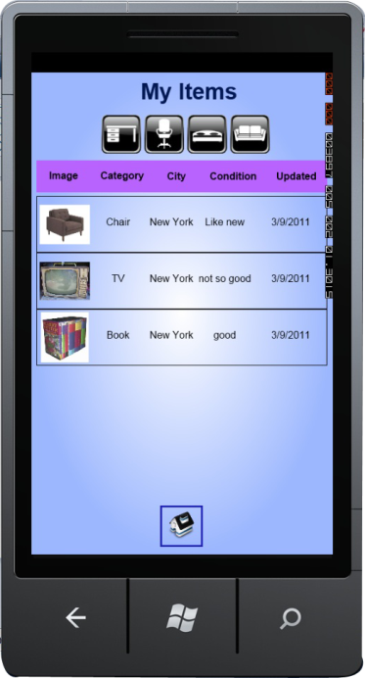

View / edit / delete my items
On the application's home page, click on 'My Items' and you'll get a list of all of your recent items that are intended to be given away. In order to edit an item details, you can simply click the desired item from the list, and you'll be able to modify the item's details or remove it if after the item is actually being given to someone, or if you changed your mind about giving it.

I want to get stuff

Search for stuff
On the application's home page, click on 'Search for Stuff' and you will be asked to fill out the details of the desired item. You must choose only one category and one state but you can select multiple sub categories, colors, cities and conditions. Specify if you wish to find indoor items, outdoor items or both, and check in the box if you wish to include only items with a picture in the search operation. Click on 'Search' and you will get all of the items that match your request. You can sort the list by any one of the table's headers. Click on an item from the list to view its full details.
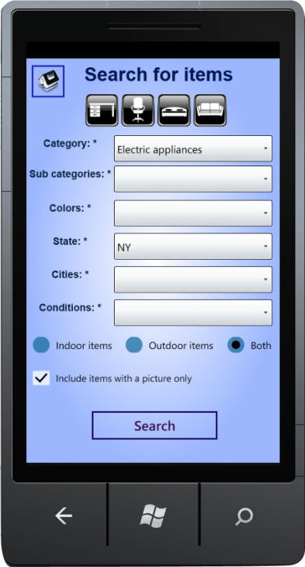
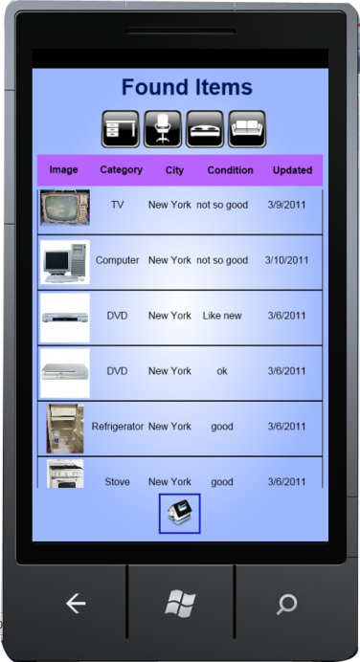
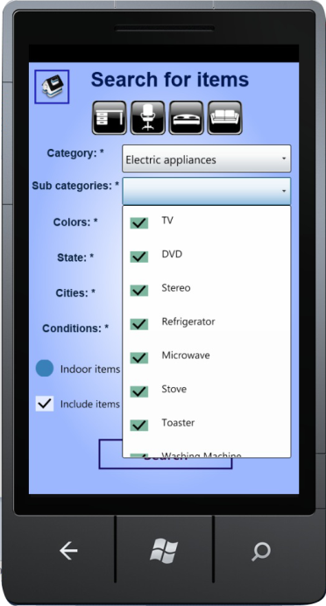

View item's details
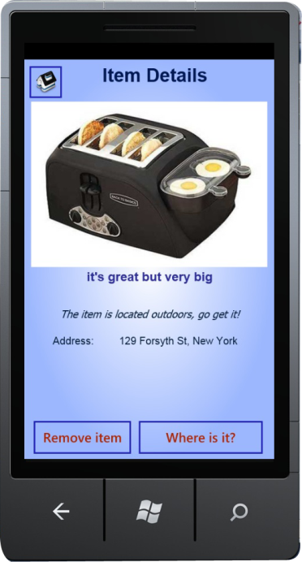
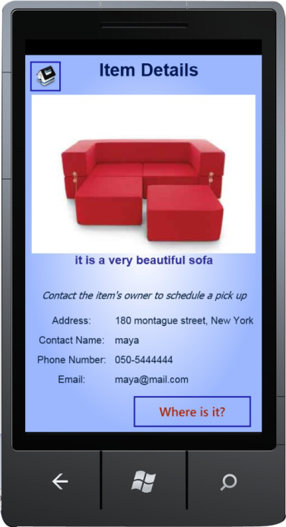
Indoor items include their owner's personal details so you'll be able to contact him or her to schedule a pick up for the item. The item's owner is responsible for deciding who actually gets it. Outdoor items maintain only their location, so the first one who gets there will be the item's rightful owner. Outdoor items also maintain the option to remove them from Freebay if you get there and take the item or if you see that it's not in its specified position, but be aware that you can't easily remove any item you want, because your location is verified against the item's actual position. If you wish to see how to get to the item's whereabouts click on the 'Where is it' button.

Get directions to item's location
After clicking on 'Where is it' you will get a map with directions on how to get to the item's whereabouts from your current location.
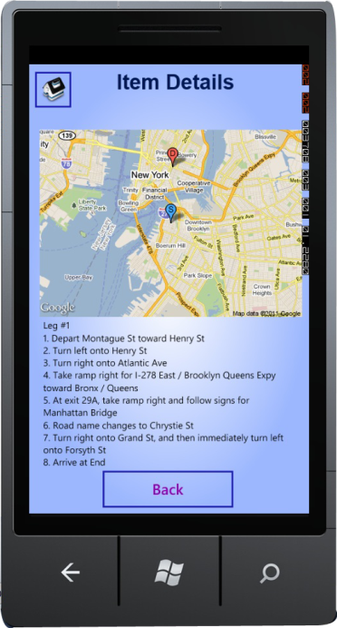

Create / edit / delete a smart agent
On the application's home page, click on 'My Smart Agent' and you will be able to define a smart agent that will notify you about specific items you are looking for. You must choose only one category and one state but you can select multiple sub categories, colors and cities. Specify if you wish to be notified only about indoor items, outdoor items or both, and check in the box if you wish to be notified only about items with a picture. Also, if you wish to be notified about items in your vicinity, check in the last box and specify a distance radius between your current location and the item's location.
